**Assignment 13 Practice Queries 1:**

**1. Find Second Highest Salary from Employee table using subquery**

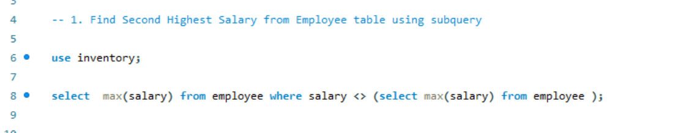

**2. Find Second Highest Salary from Employee table using "not" any where in the query**

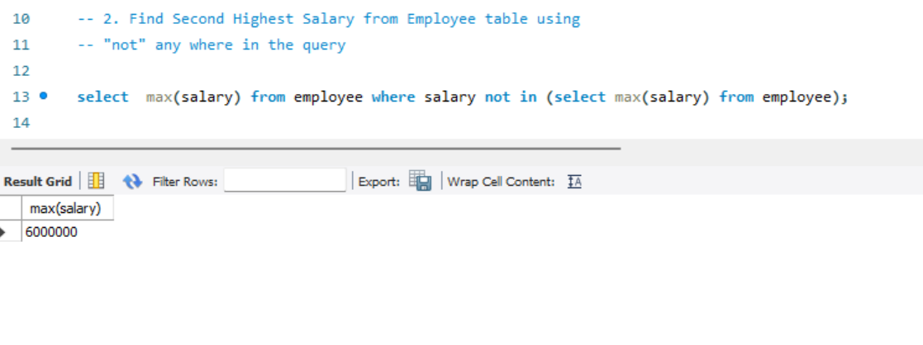

**3. Find Second Highest Salary from Employee table using inline table**

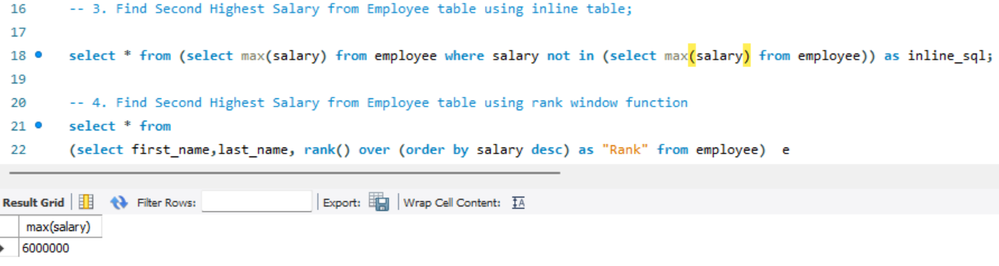

**4. Find Second Highest Salary from Employee table using rank**

**5. Find Second Highest Salary from Employee table using limit**

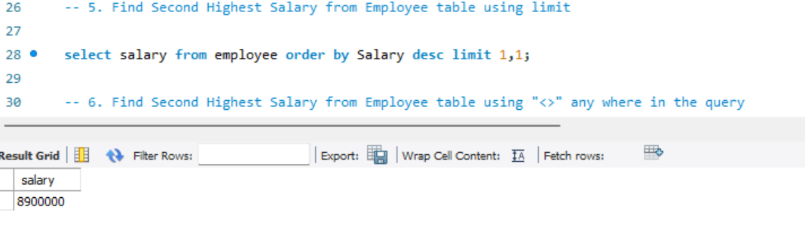

**6. Find Second Highest Salary from Employee table using "<>" any where in the query**

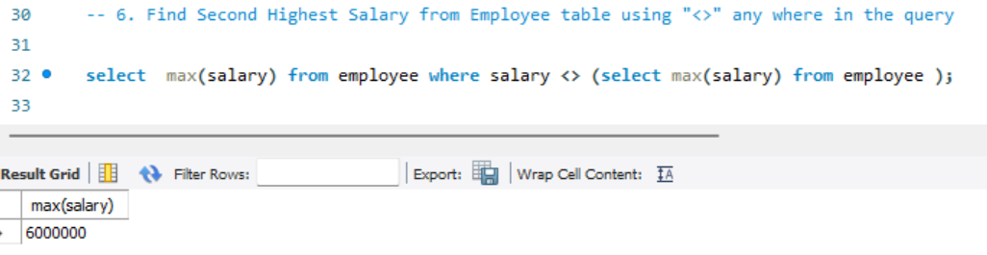

**7. Find Second Highest Salary from Employee table using "max() function and subquery" anywhere in the query**

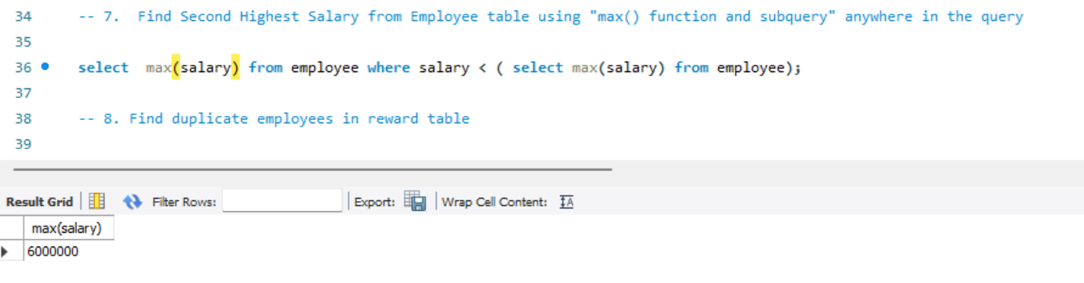

**8. Find duplicate employees in reward table**

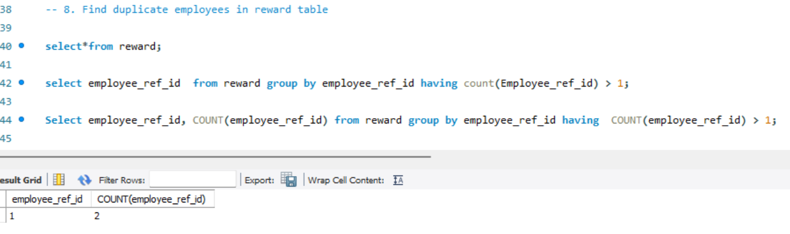

**9. Rank each salary using rank function**

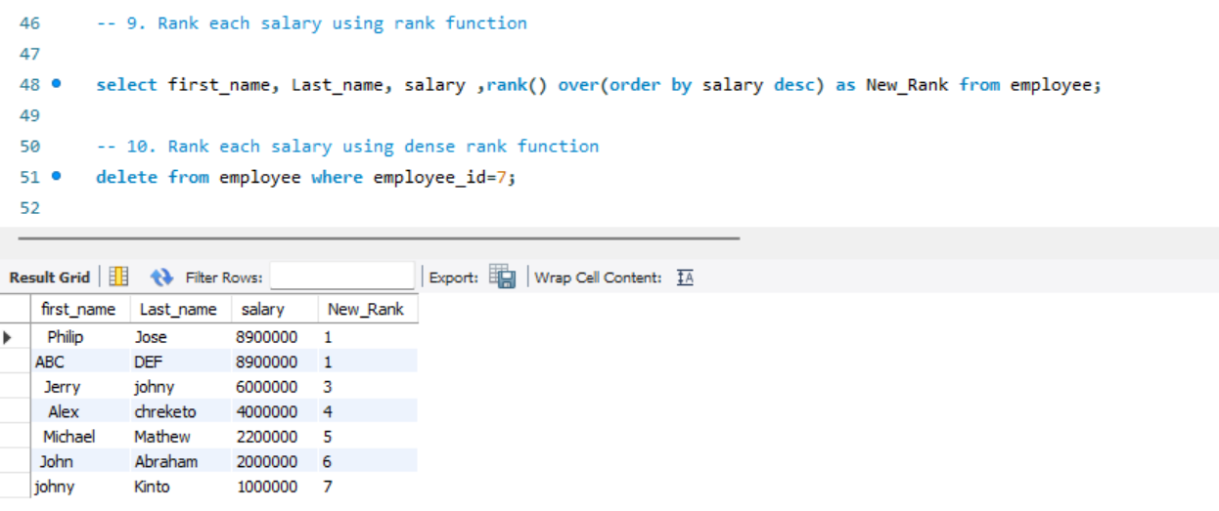

**10. Rank each salary using dense rank function**

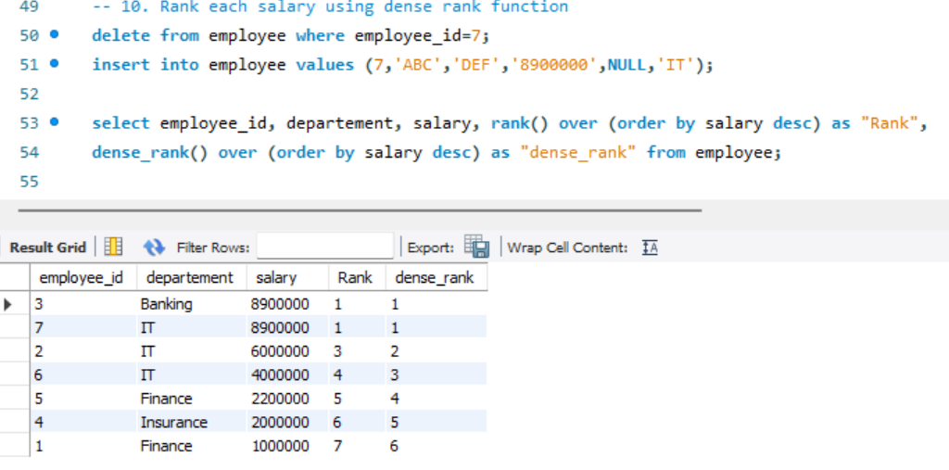

**11. Rank each salary "with out" using rank functions**

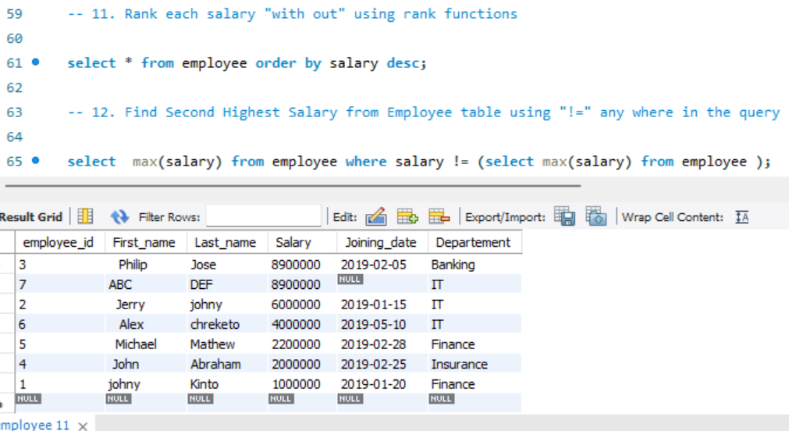

**12. Find Second Highest Salary from Employee table using "!=" any where in the query**

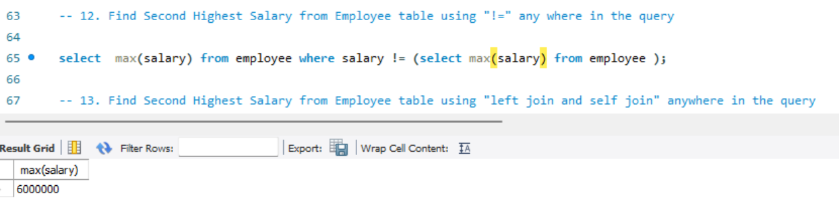

**13. Find Second Highest Salary from Employee table using "left join and self join" anywhere in the query**

**14. Find Second Highest Salary from Employee table using Row_number() function**

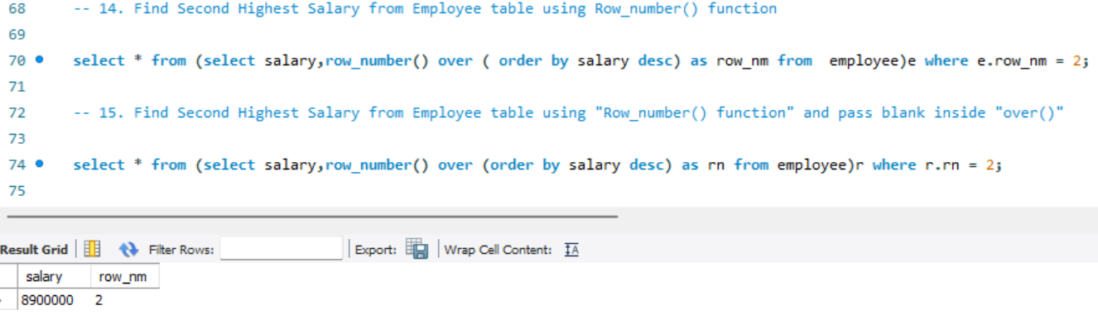

**15. Find Second Highest Salary from Employee table using "Row_number() function"**

